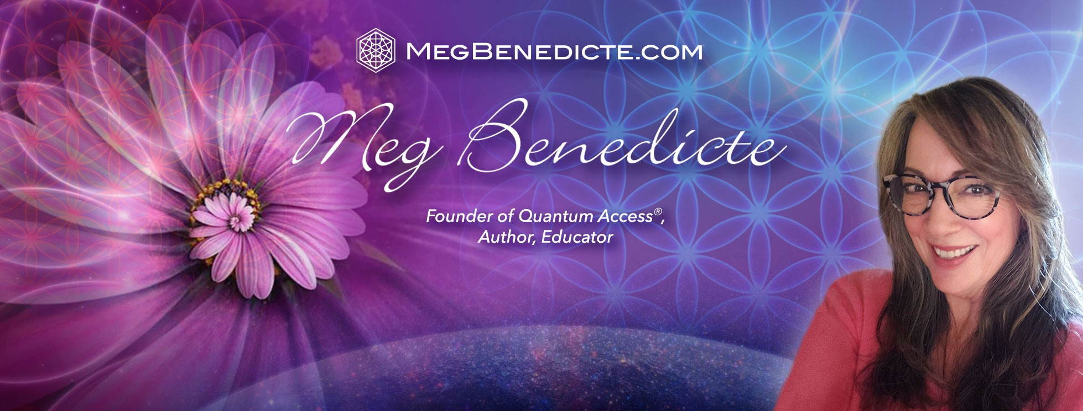
Spiritual Teacher, Author, Luminary. Over the past three decades, Meg Benedicte has become a notable pioneer and international Master Healer in Quantum Healing and Spiritual Activations, first through her own transformation and eventually working with clients spanning the globe.
Meg recognized her passion and gift for seeing beyond the physical world and into the subtle energies and patterns of the quantum holofield. As an international expert in Quantum Healing, Meg experienced a profound awakening in 1994 that activated her inherent template for performing and understanding the mechanics of ancient alchemy.
Meg is the Founder of the advanced Quantum Access® method, a powerful tool for spiritual transformation at the quantum level. Meg Benedicte is an avid explorer of the Ancient Mystery School Tradition and offers Quantum Access® to clients, students and global audiences to enhance living Soul purpose and embodiment. Visit Meg’s sites at https://newearthcentral.com, https://megbenedicte.com and Quantum Access® Academy at https://quantumaccess.newearthcentral.com/

